SCD LAB 12 TASK:
NAME: Laiba Azhar
ID: 65904
CLASS-ID: 119752

Cafe Management System Project
This project fulfills:
- Tkinter GUI
- MVC Architecture
- N-Tier Architecture
- Exception Handling
- Refactoring
- unittest / pytest Testing
- SQLite Database
- EXE Deployment
- UML Diagrams

1. Project Overview

Project Title
Cafe Management System

Objective
The system manages:
- Food Items
- Prices
- Orders
- Cafe Records
The admin can:
- Add Items
- Update Items
- Delete Items
- View Menu

2. Technologies Used
Technology | Purpose
Python | Programming
Tkinter | GUI
SQLite | Database
unittest / pytest | Testing
PyInstaller | EXE creation
GitHub | Version control

3. N-Tier Architecture
Presentation Layer
↓
Business Logic Layer
↓
Validation Layer
↓
Data Access Layer
↓
Database Layer

Database:
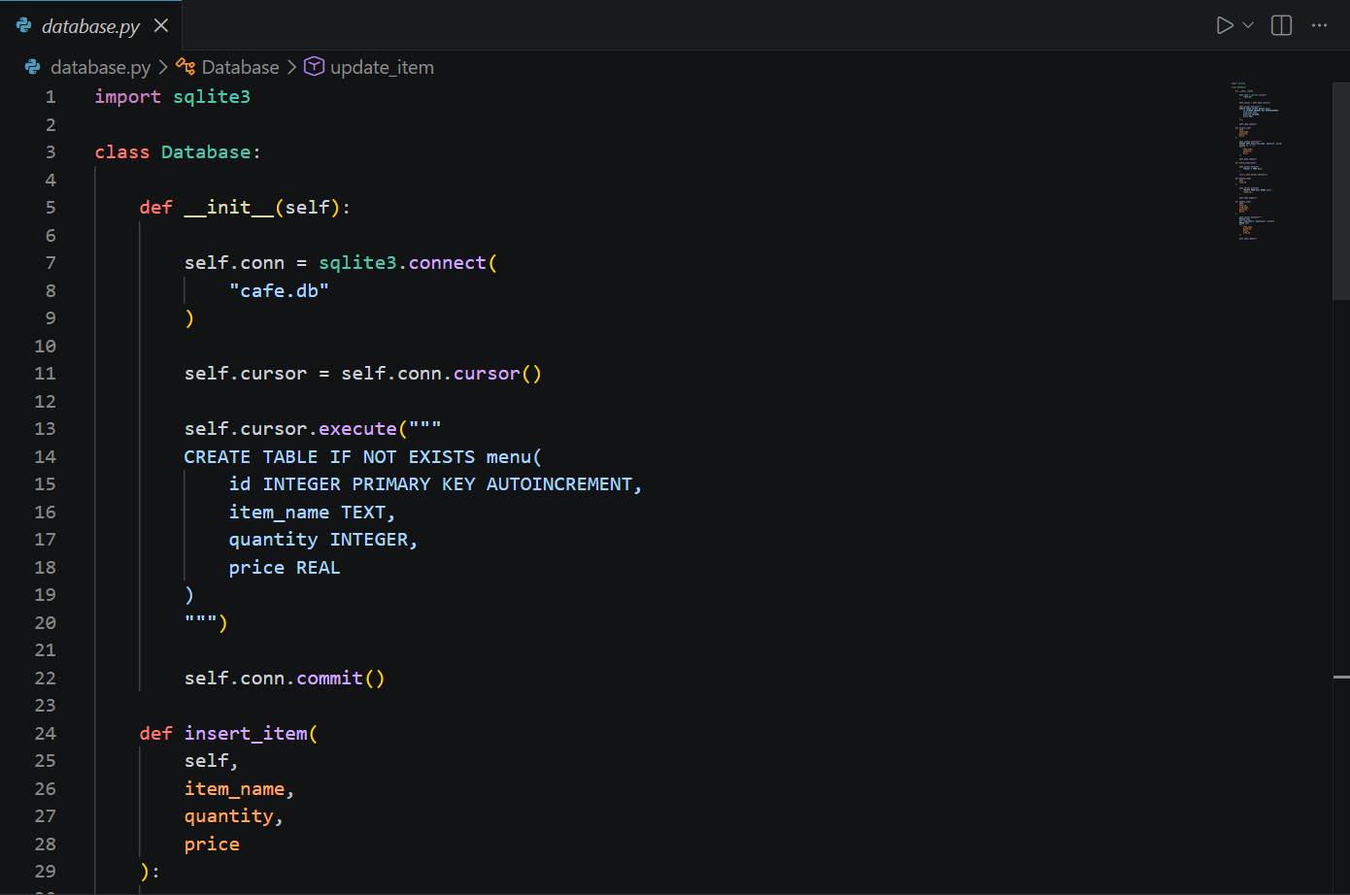
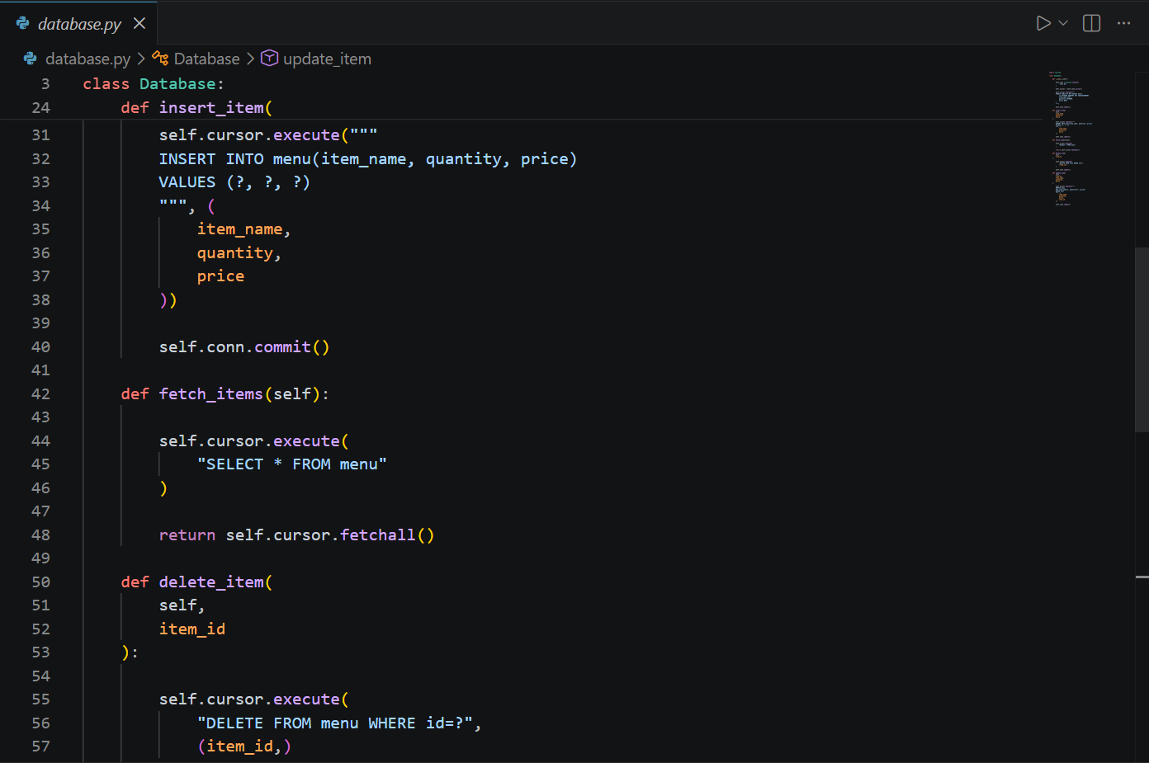
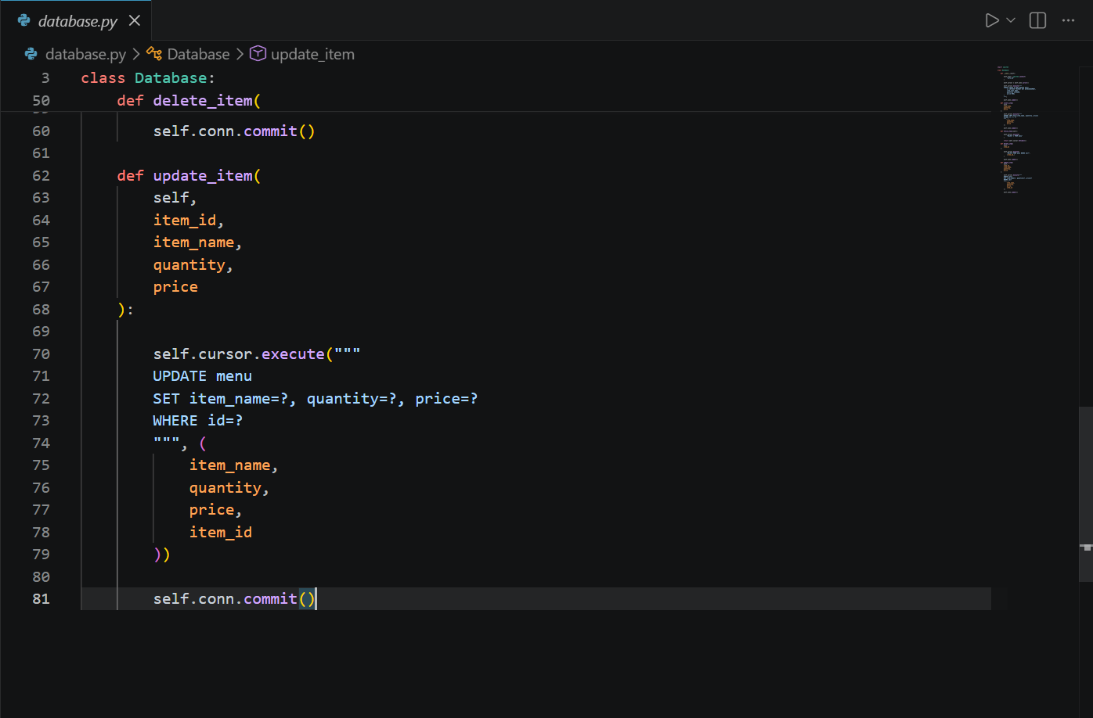

Validation Layer:
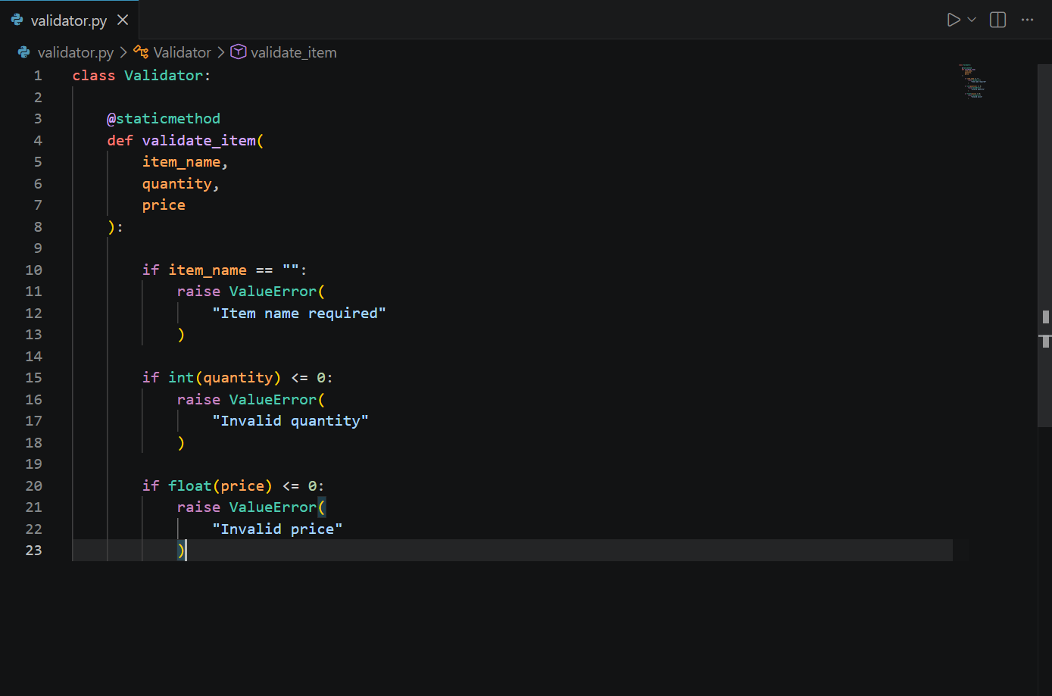
Business Logic Layer:
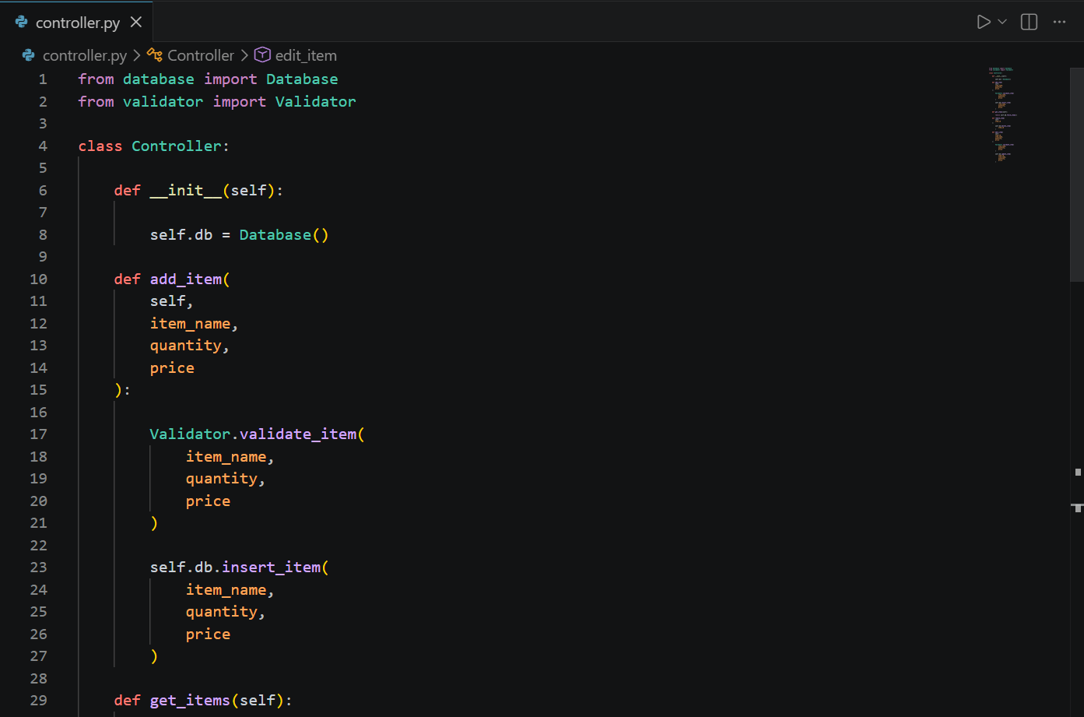
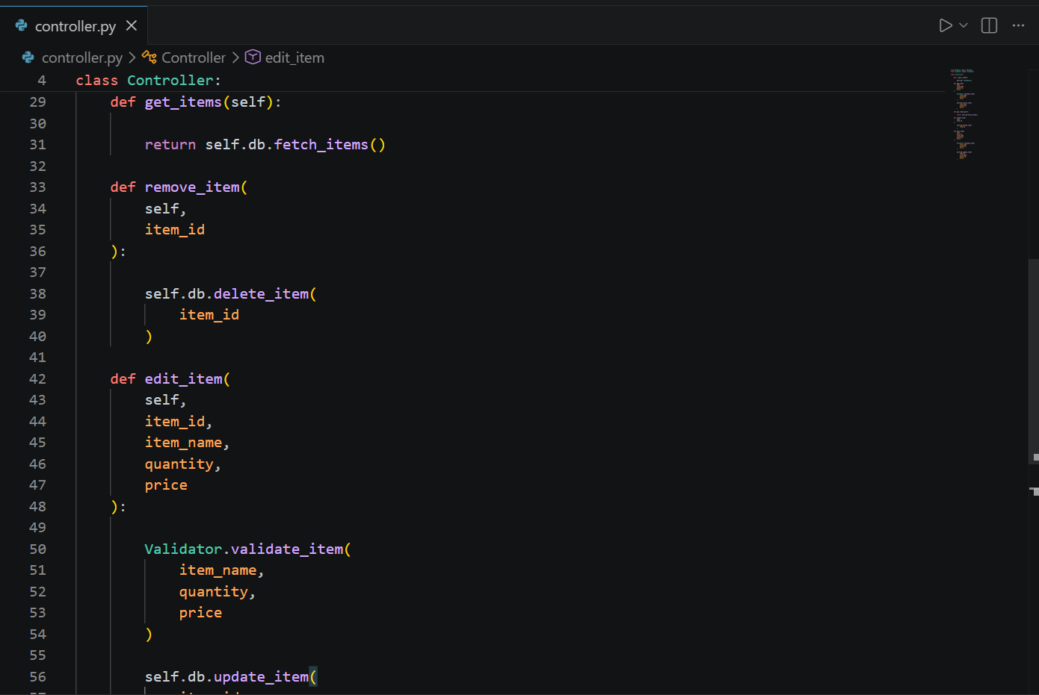
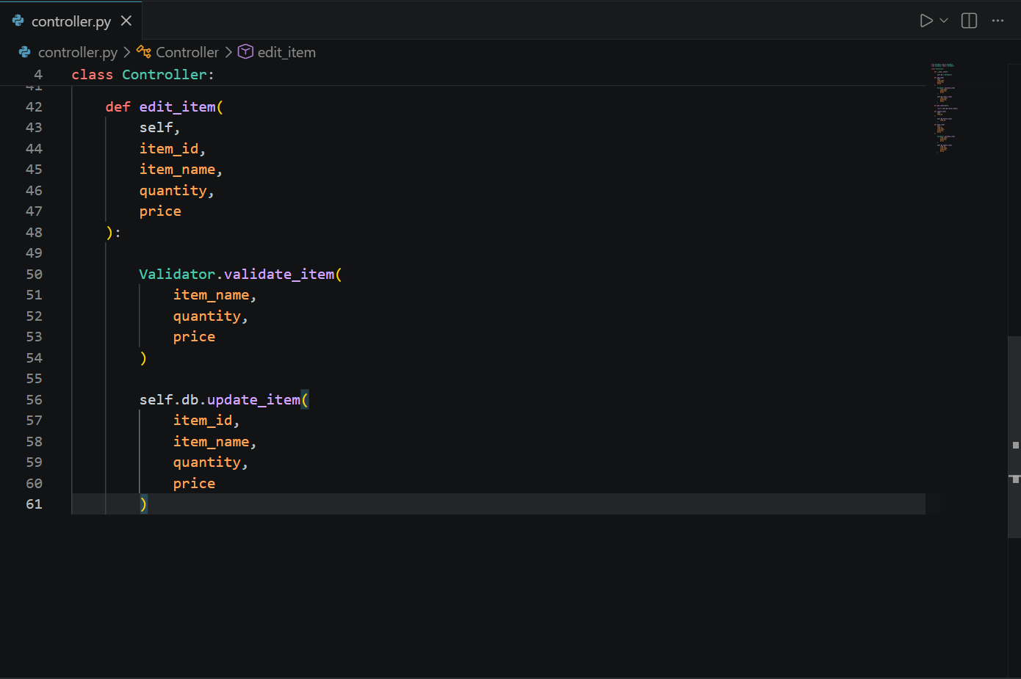
GUI Design: 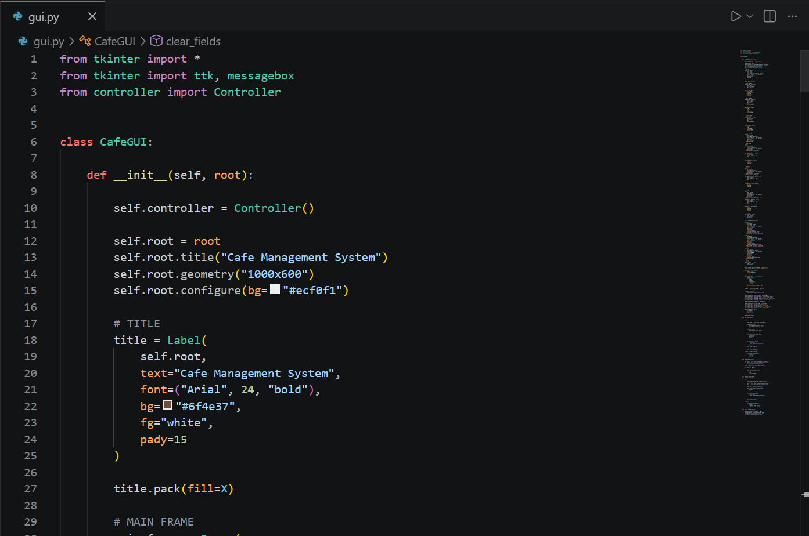
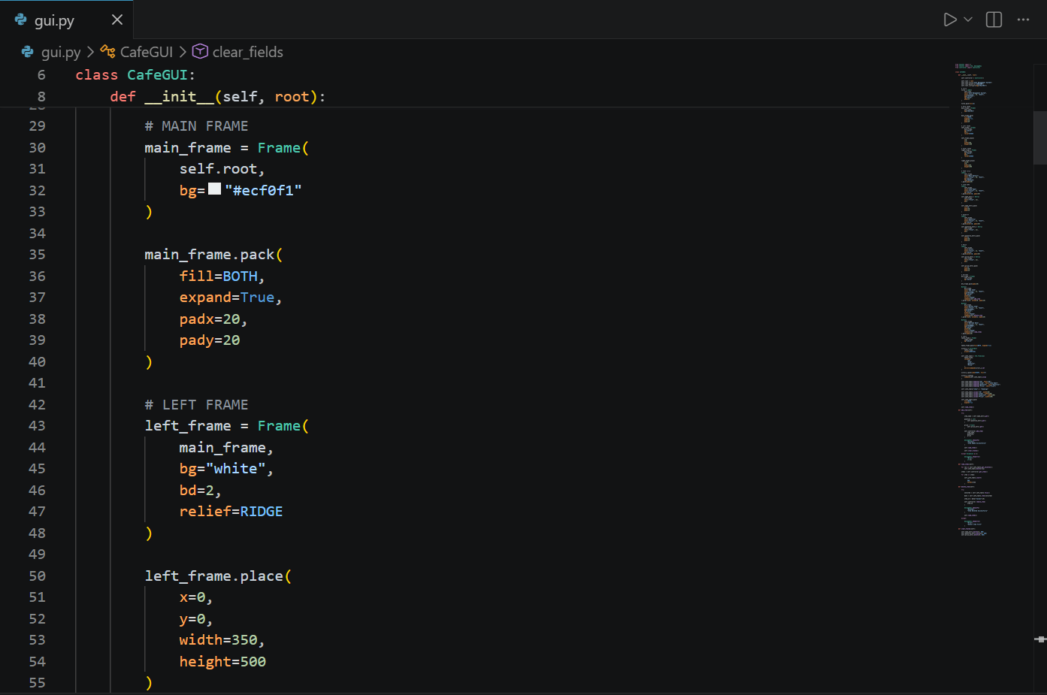

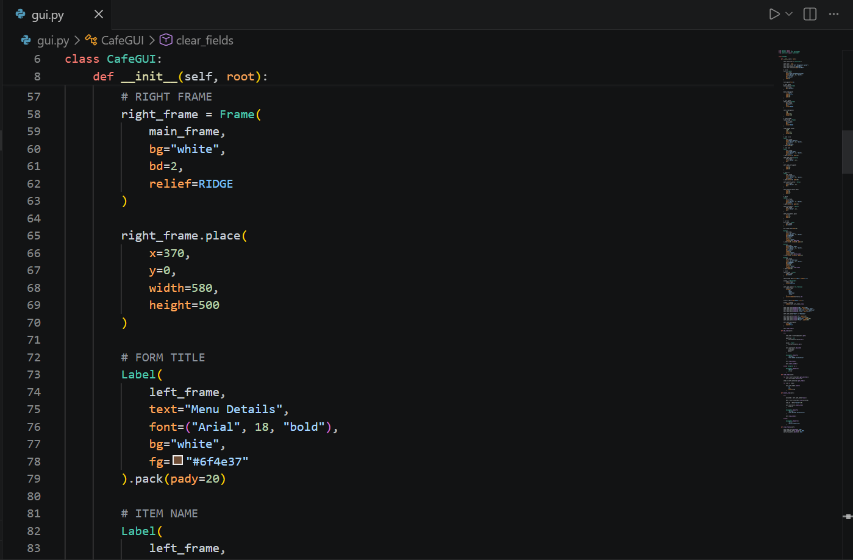

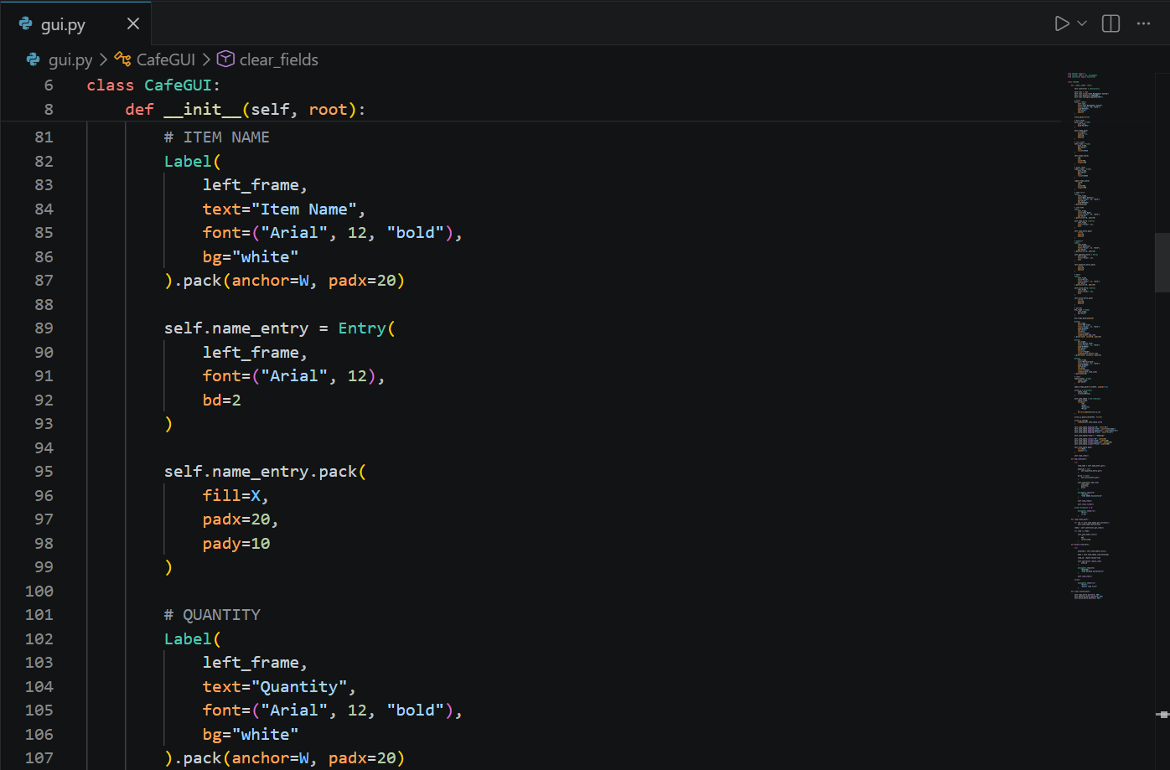

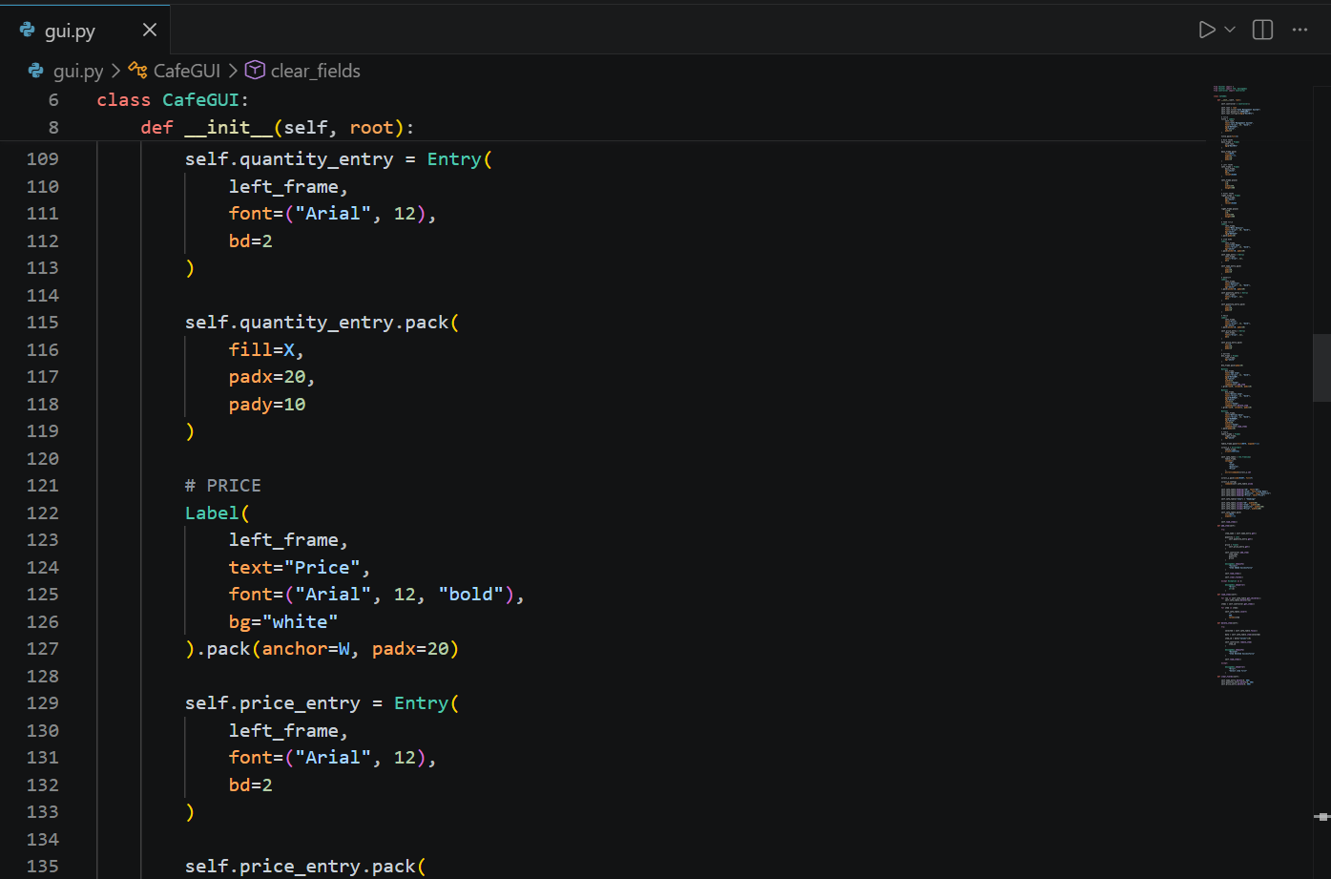

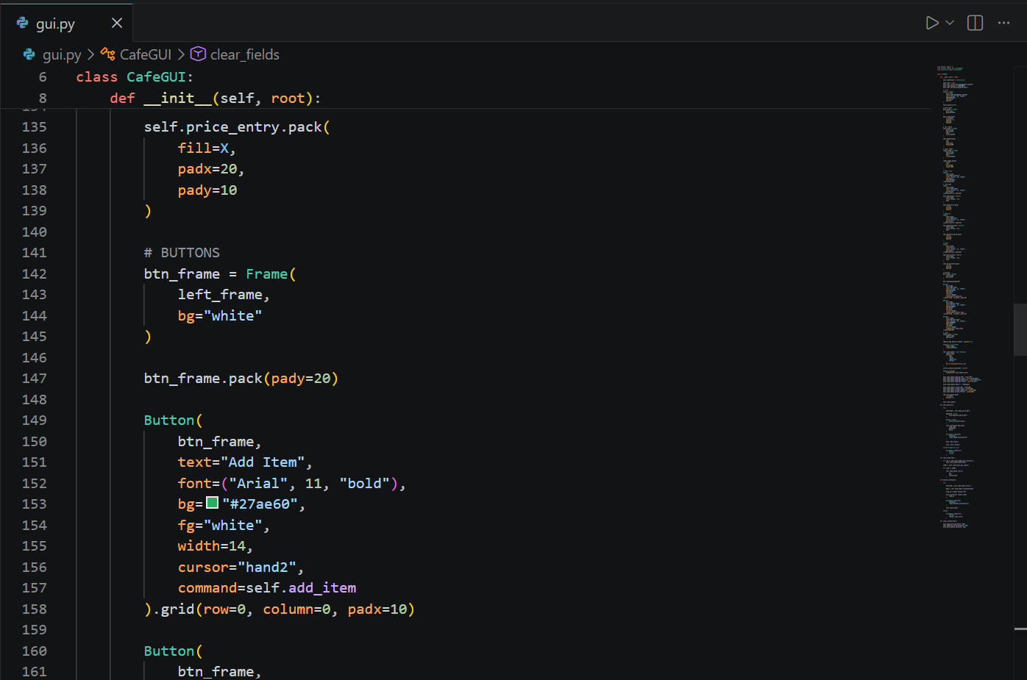

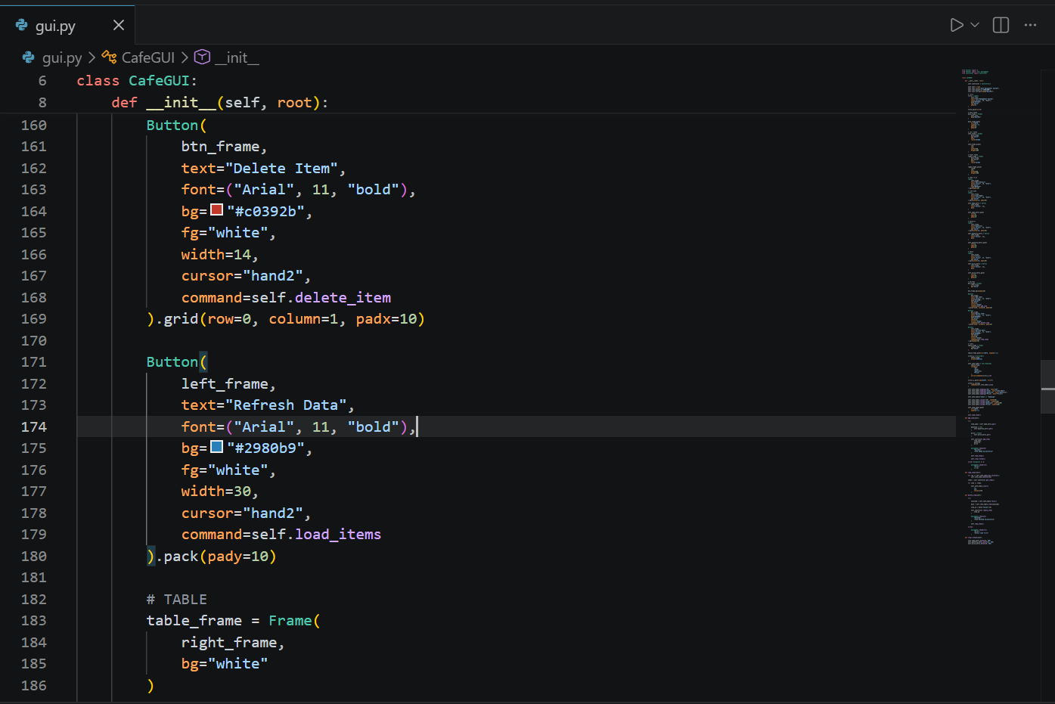
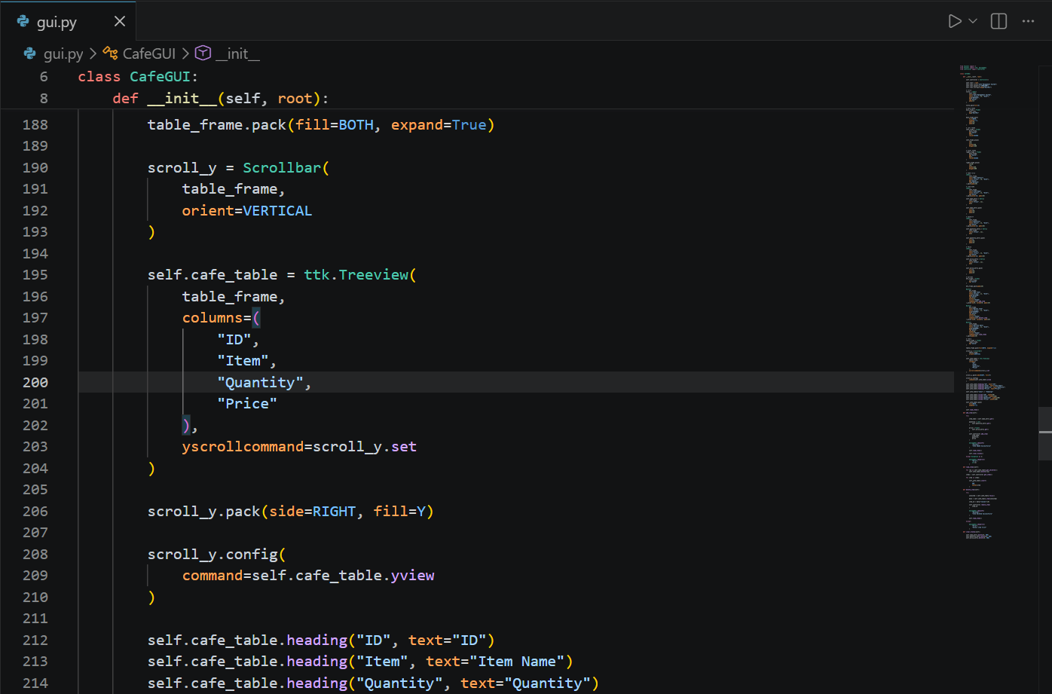

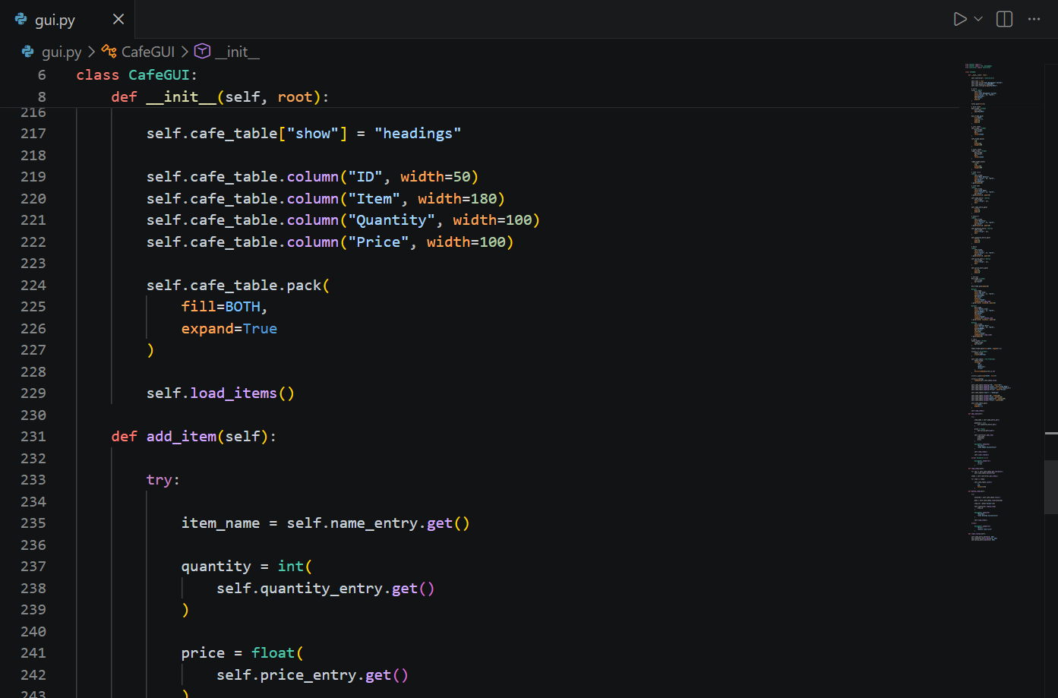

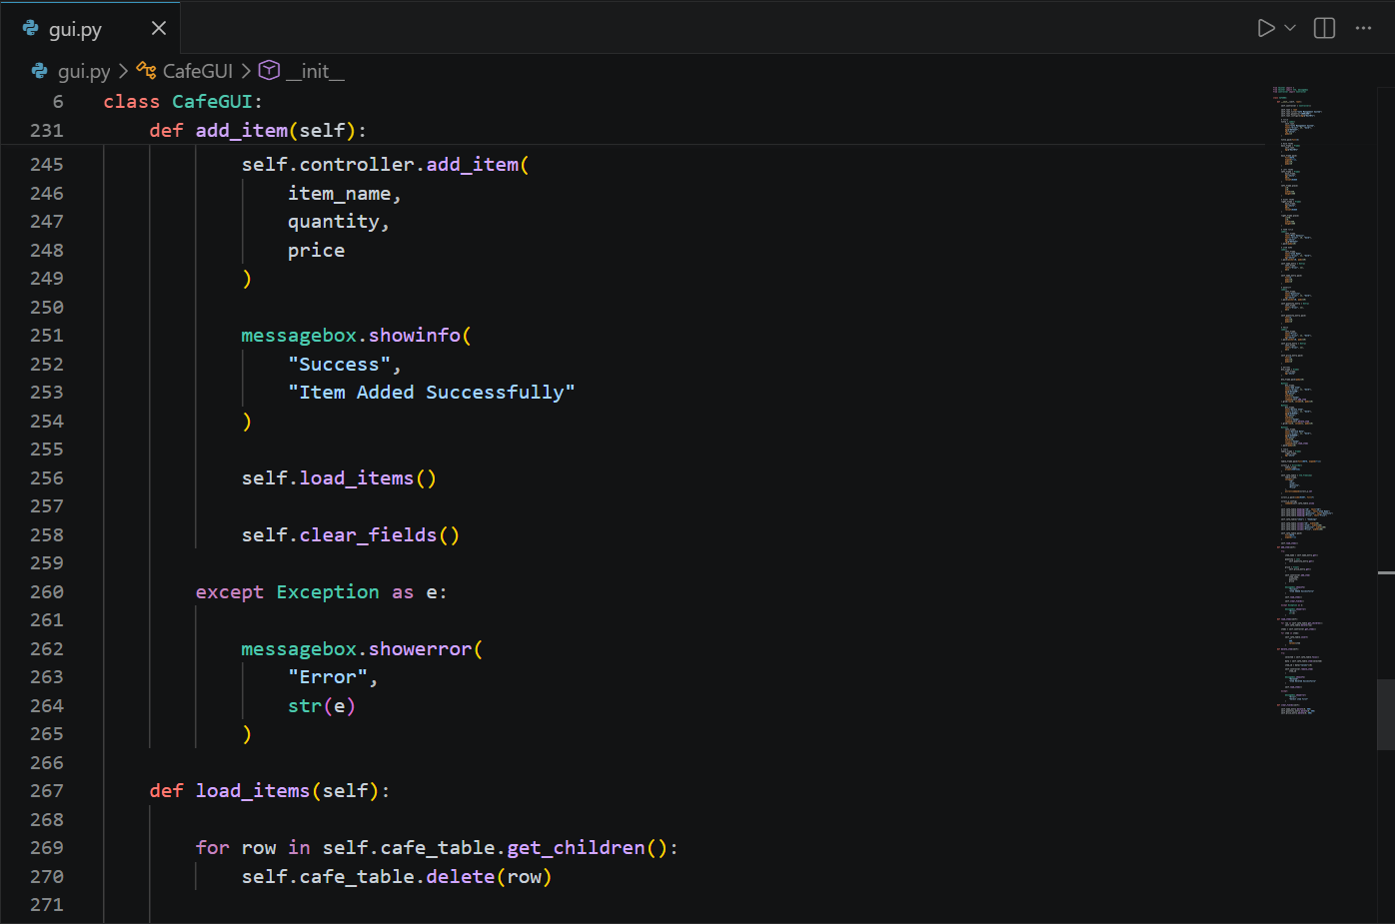

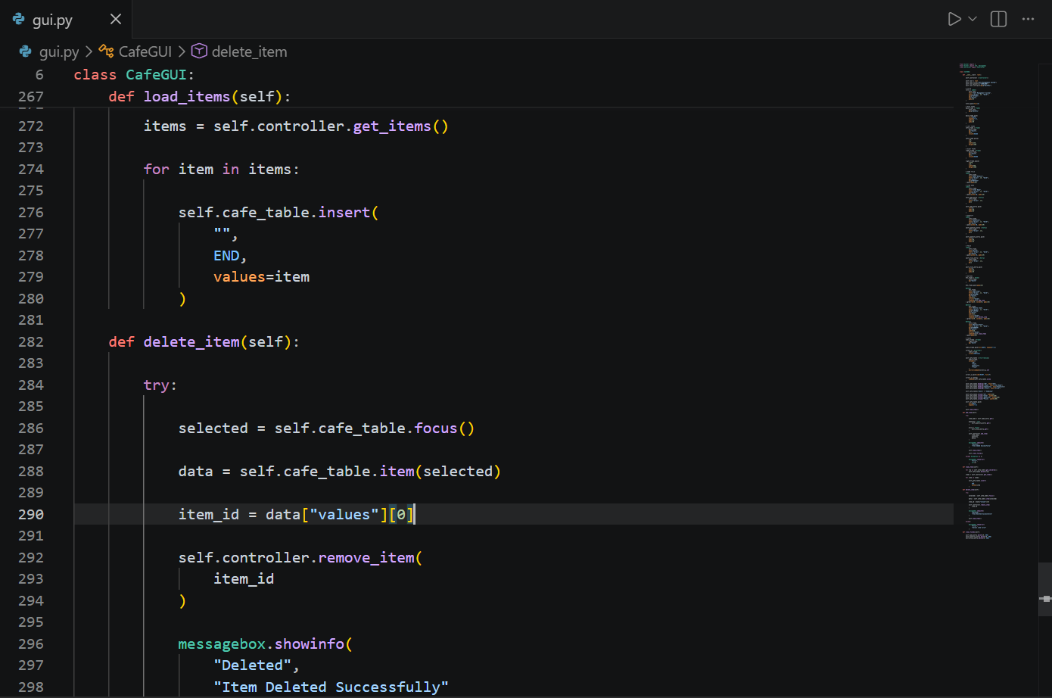
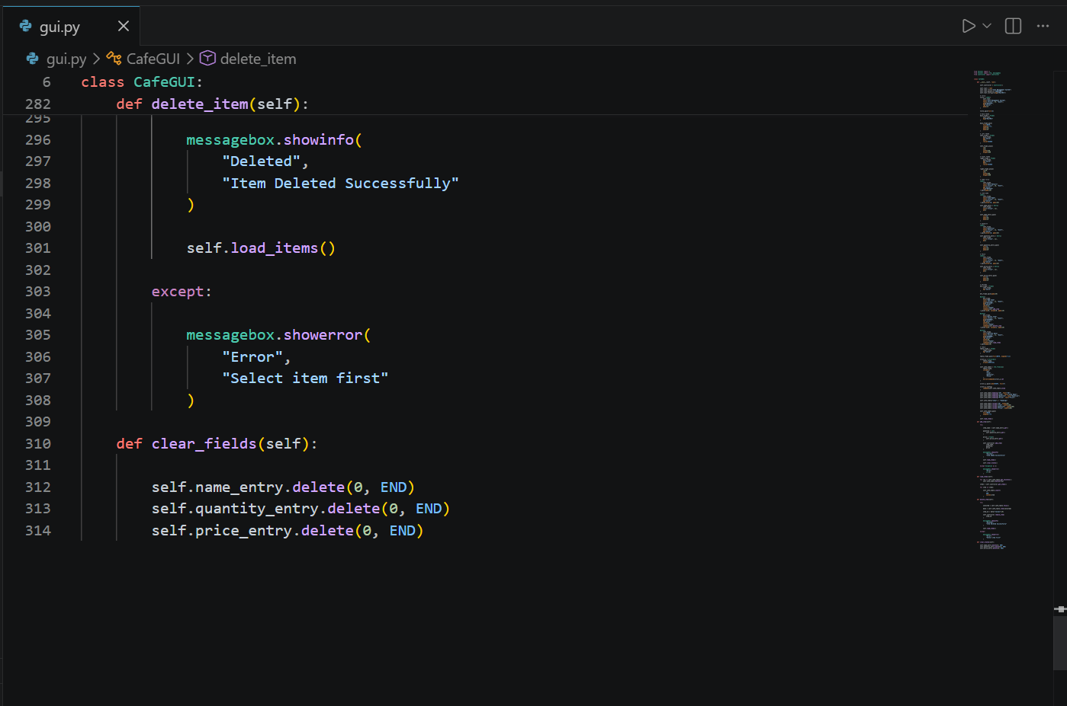

MAIN:
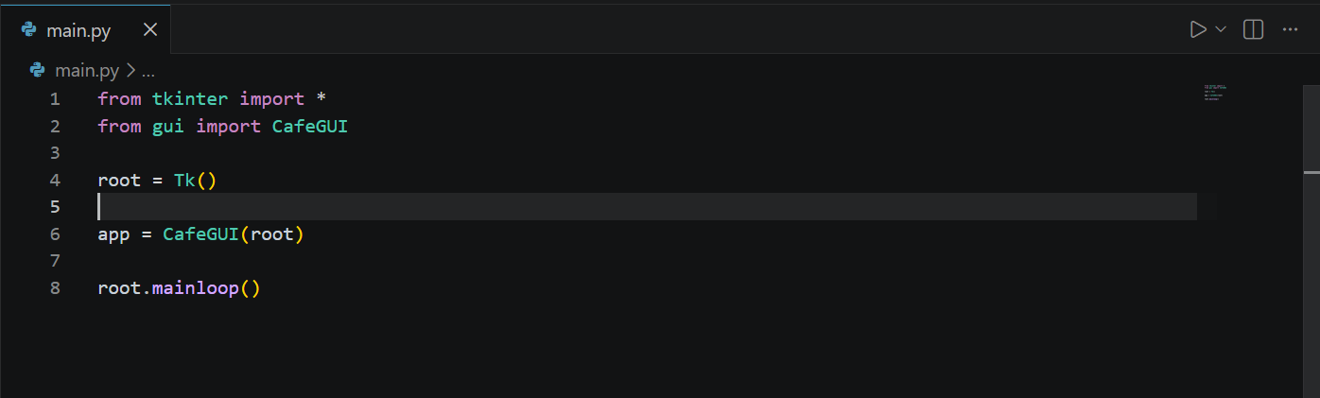

OUTPUT:
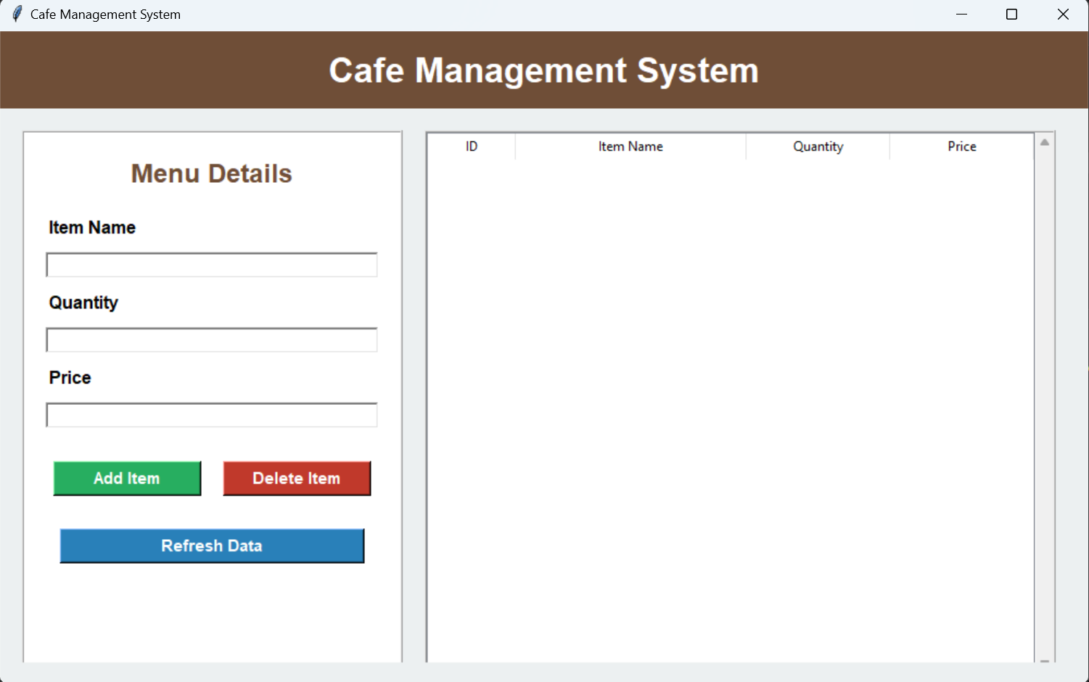

PYTEST TESTING:
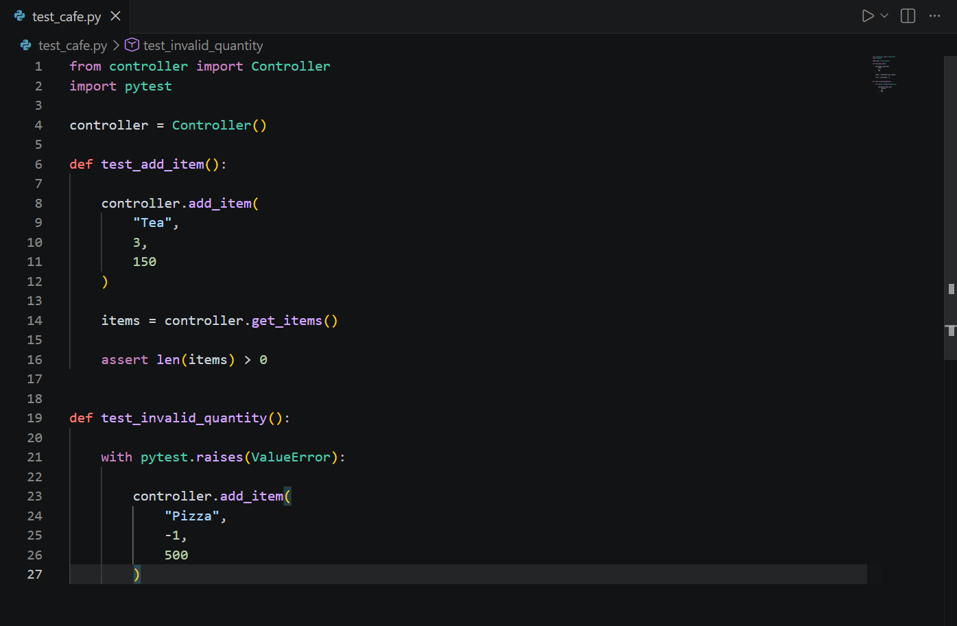
OUTPUT OF PYTEST TESTING:
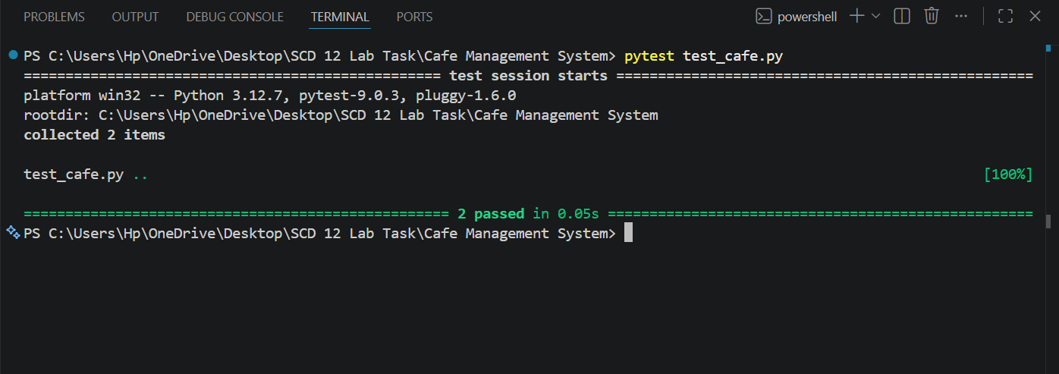

UNIT TESTING:
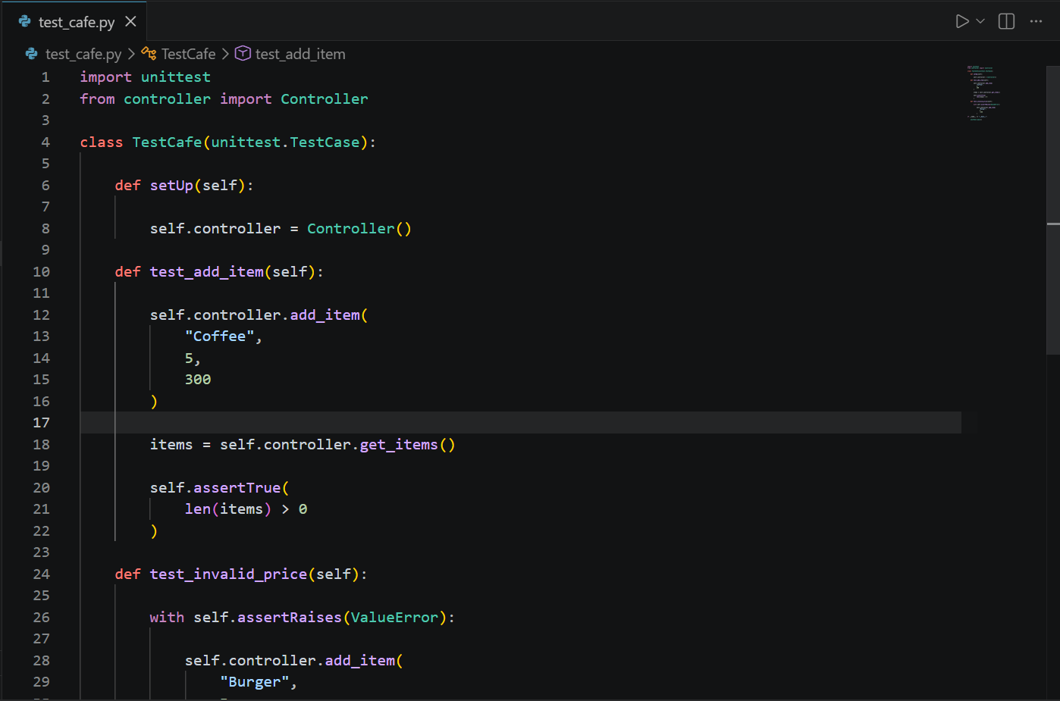
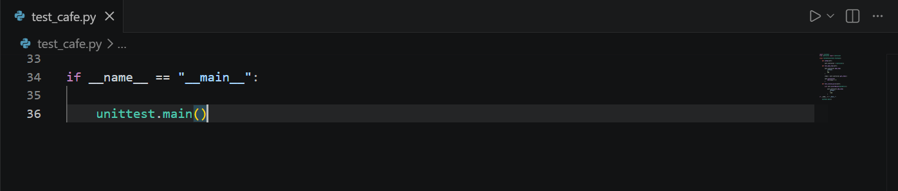

OUTPUT OF UNIT TESTING:
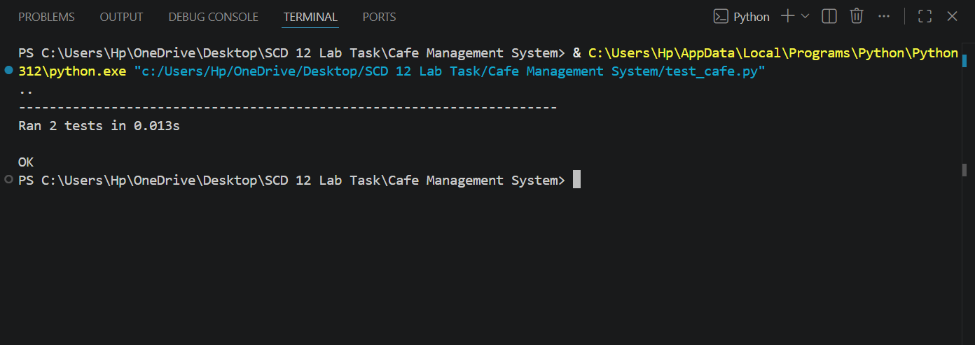

USE CASE DIAGRAM:
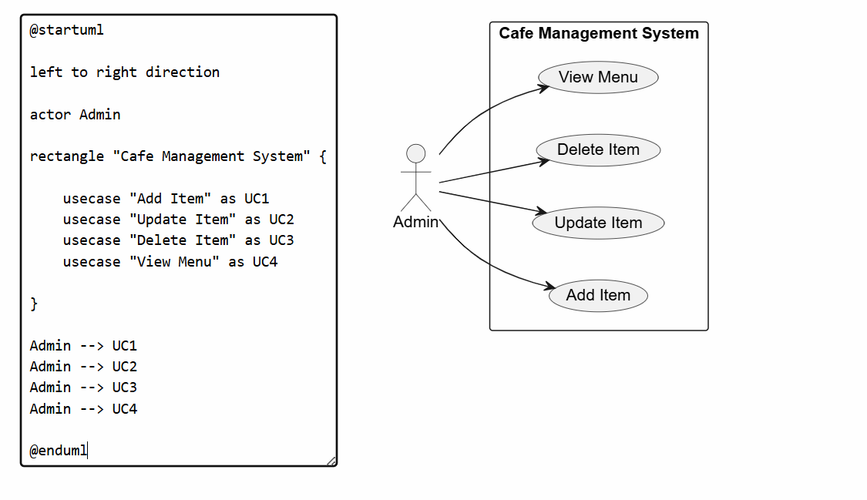

CLASS DIAGRAM:
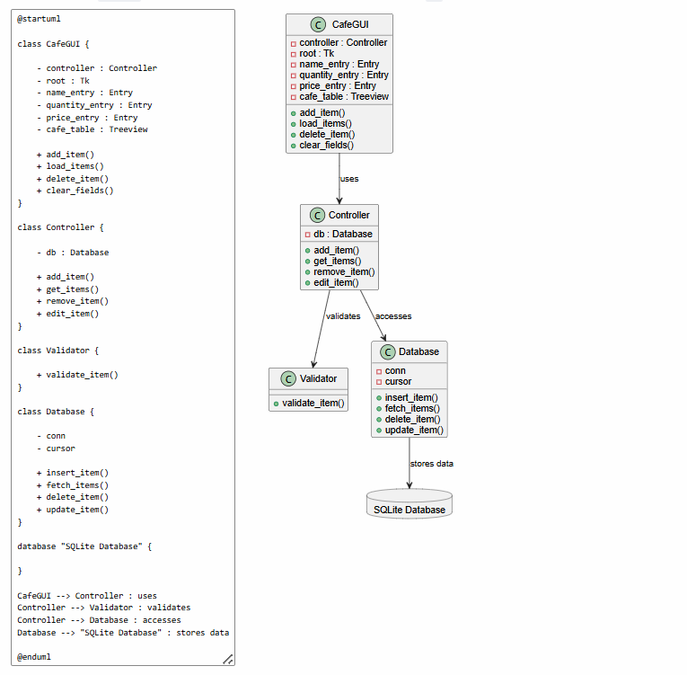

Converting Into EXE File:
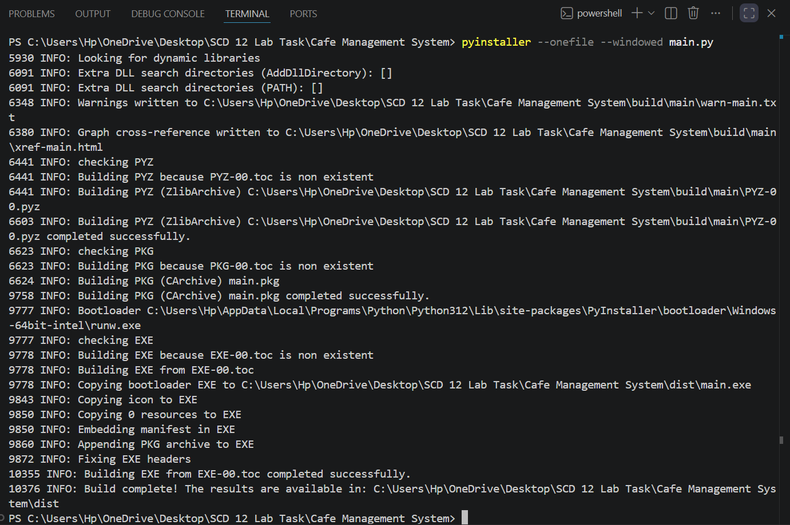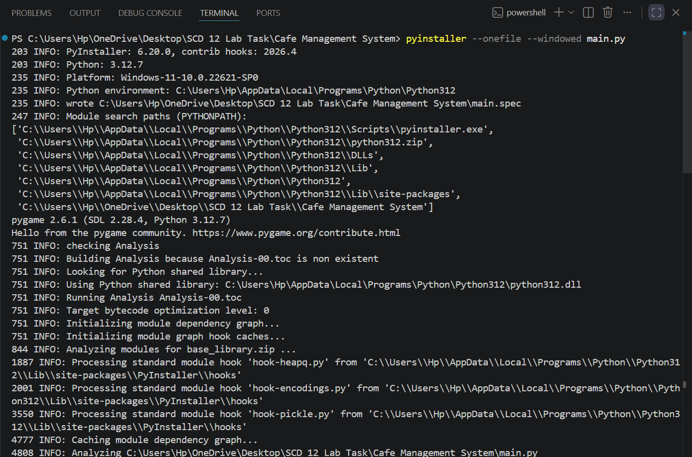
Running .exe File:
